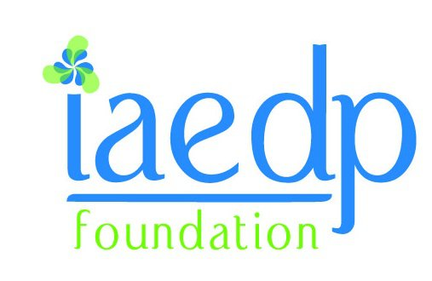

FOR IMMEDIATE RELEASE

Contact: Susie Lomelino/Sarah Drew
slomelino@calisepartners.com/publicrelations@calisepartners.com

214.269.2092/214.269.2087

2012 “Imagine Me Beyond What You See” Mannequin Entries Inspire!

Provocative Body Image Art Competition Returns to The iaedp Foundation’s Symposium 2012 with More Entries and Profound Emotions

PEKIN, ILL. (February X, 2012) –The International Association of Eating Disorder Professionals (iaedp) invites attendees of Symposium 2012 in Charleston, S.C., to take in the emotionally-charged display of entries from this year’s Imagine Me Beyond What You See Annual Body Image Mannequin Art Competition and Awareness Project. This awareness-through-art project encourages art therapists from treatment centers and private facilities, as well as recovering clients, students and the general public, to design mannequins that reflect their perception of beauty with the theme’s emphasis on seeing beyond the physical image.
With 10 submissions from treatment centers and private practices and two individual submissions, this year’s submissions increased from last year’s nine entries and continue to impress and inspire. Entries include:

- Humanity by Carolina House Eating Disorder Treatment in North Carolina
- The Onion by Casa Rosada/Oliver-Pyatt Centers
- Ying-Yang/Love-Hate by Women of Casa Verde Oliver-Pyatt Centers
- Shattered by Dr. Susan J. Mendelsohn’s Eating Disorder Therapy Group
- The Light Within by Eating Recovery Center’s Behavioral Hospital for Children and Adolescents/ Katie Pruitt, ATR-BC
- Mariposa by Eating Recovery Center’s Partial Hospital Program/Lisa Talucci, MA, LPC, ATR
- Tree of Life by Nutrition Clinic's Intensive Outpatient Programs and Sol Stone Partial Hospitalization Program
- Unraveled by Rebecca Tishman
- Skin Deep by Reflections Eating Disorder Treatment Center at Dominion Hospital with Art Therapist Amy Greenough and Program Director Felicia Kolodner
- Bloosoming into Wholeness by Residents and Alumni of The Renfrew Center of Florida
- Bella by Rogers Memorial Hospital/ Tina Szada, ATR-BC
- She is a Tree of Life by Sara Burchfiel
All mannequin entries will be mounted and displayed, allowing Symposium 2012 attendees to participate in the Professionals’ Choice award by voting for their favorite. To see this year’s entries and read their descriptions, visit our website at www.iaedp.com and look for the multicolored mannequin.
Imagine Me Beyond What You See is an annual Body Image Mannequin Art Competition and Awareness Project designed to promote a healthy awareness and acceptance of body images. While mixed mediums are allowed, photographs of all entries were submitted to qualify for the contest and judged on clarity of theme, creativity, quality of composition and design, along with the overall impression and presentation of the piece. This year’s judges include a distinguished panel of eating disorder professionals, art therapists, a representative from the American Art Therapy Association (AATA) and professional artist Fritz Liedtke.
The top 5 finalists will be named on Tuesday, Feb. 28. The winner, along with awards for First Runner-Up, Honorable Mention and Professionals’ Choice will be announced during the Symposium on Saturday, March 23 during the Imagine Me Awards and Chapter Networking Reception.

MORE
About iaedp:
Since 1985, the International Association of Eating Disorders Professionals Foundation has provided education and training standards to an international and multidisciplinary group of various healthcare treatment providers and helping professions.
iaedp is excited about Charleston as the site for iaedp Symposium 2012! For more information, visit: International Association of Eating Disorders Professionals.

